NAME : S SURENDER

REG NO:1924260070

Set 17: Employee Performance Analysis
Data Visualization using R

Aim
To analyse employee performance using a line chart, a bar chart, a table and a dashboard in R.

Procedure
- Open RStudio and load the packages ggplot2 and gridExtra (install them once with install.packages(c("ggplot2", "gridExtra"))).
- Create the employee data as a data frame.
- Question 1: draw the line chart of performance score against years of service with geom_line().
- Question 2: draw the bar chart of employees per department with geom_bar().
- Question 3: make the table with tableGrob().
- Question 4: join the charts and the table into a dashboard with arrangeGrob().
- Run the code and note the output and the figures.

R Code
library(ggplot2); library(gridExtra)

# Dataset
emp <- data.frame(Employee_ID = 1:3, Department = c("Sales","HR","Marketing"), Years = c(5, 3, 7), Score = c(85, 92, 78))
print(emp)
cat("Average score:", mean(emp$Score), "\n")

# 1. Line chart - performance over years of service
p1 <- ggplot(emp, aes(Years, Score)) + geom_line() + geom_point(size = 3) + geom_text(aes(label = Department), vjust = -1) +
labs(title = "Performance vs Years of Service", x = "Years of Service", y = "Performance Score")

# 2. Bar chart - employees per department
p2 <- ggplot(emp, aes(Department, fill = Department)) + geom_bar(show.legend = FALSE) + labs(title = "Employees per Department", x = "Department", y = "Employees")

# 3. Table
tb <- tableGrob(emp, rows = NULL)

# 4. Dashboard
dash <- arrangeGrob(p1, p2, tb, layout_matrix = rbind(c(1,2), c(3,3)), top = "Employee Performance Dashboard")

ggsave("set17_q1.png", p1, width = 6, height = 4, bg = "white") ggsave("set17_q2.png", p2, width = 6, height = 4, bg = "white")
ggsave("set17_q3.png", arrangeGrob(tb, top = "Employee Performance Table"), width = 5, height = 2, bg = "white") ggsave("set17_q4.png", dash, width = 12, height = 8, bg = "white")

Output
1
2
3
Employee_ID Department Years Score
1 Sales 5 85
2
HR 3 92
3 Marketing 7 78
Average score: 85

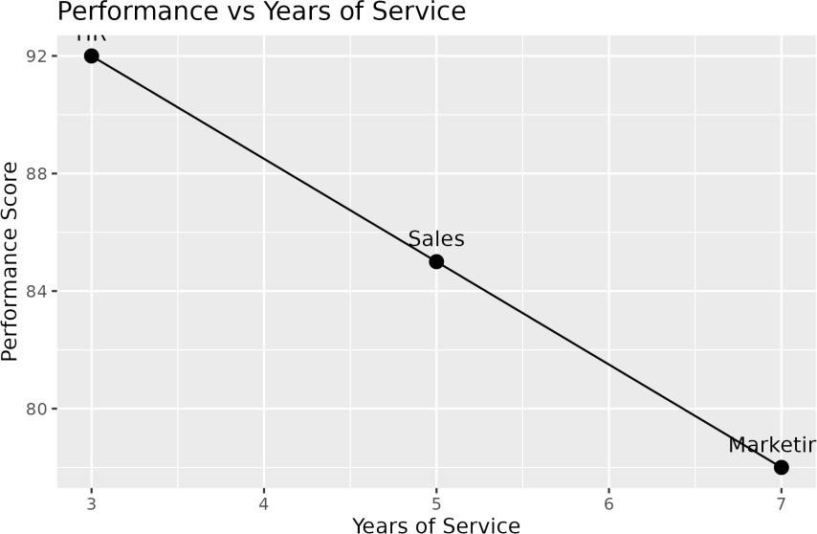

Figure 17.1: Q1 - Performance line chart
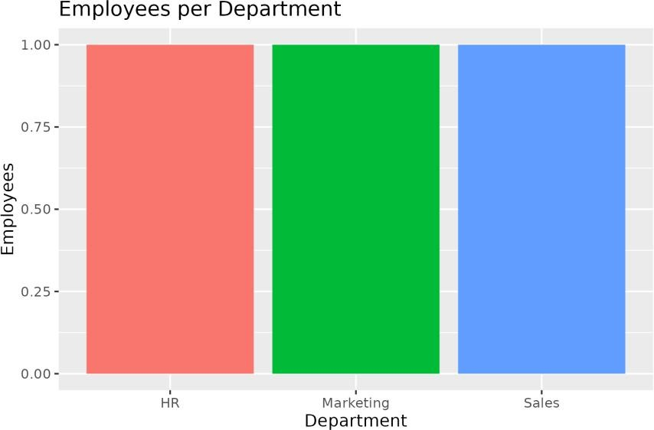

Figure 17.2: Q2 - Employees per department
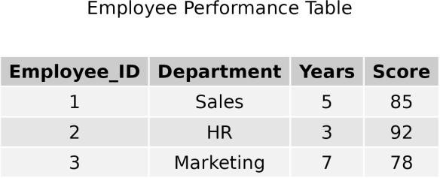

Figure 17.3: Q3 - Employee performance table

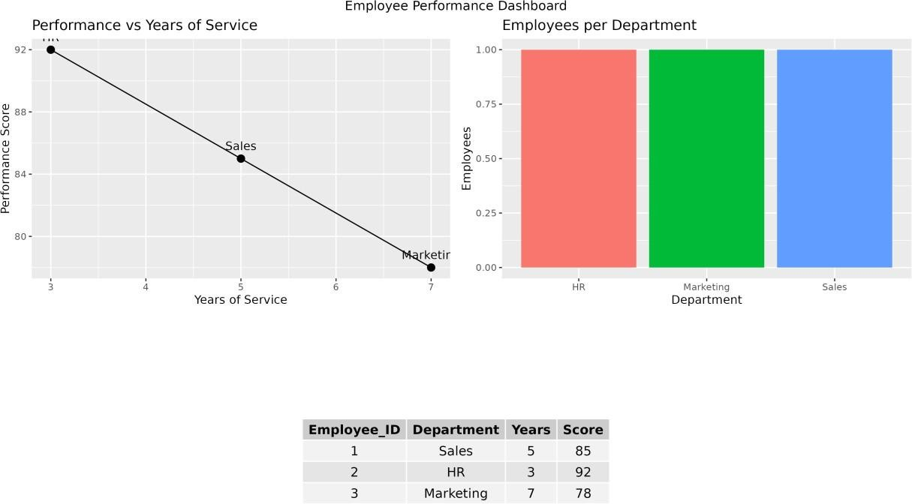

Figure 17.4: Q4 - Dashboard

Result
  - The average performance score is 85.
  - The score falls as years of service increase (92, 85, 78), but there are only 3 employees.
  - Each department has one employee.

